Chapter 7, Solution 15

(a) 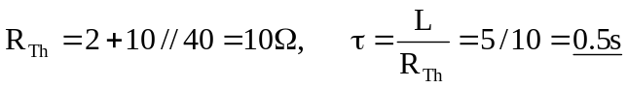
(b) 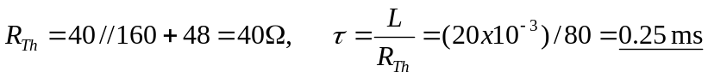

(a) 10 Ω, 500 ms (b) 40 Ω, 250 µs

